Transformations Name _________________________
A2RCC U7D1 Homework

- The function $f(x)$ is shown. A second functions, g, is defined by $g\left(x\right)=f\left(x-3\right)+1$.
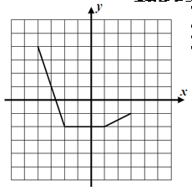
- What is the value of $g(0)$? Shw how you arrived at your answer.

- Identify how the graph of f has been transformed to produce the graph of g and sketch it on the grid.

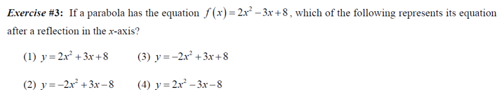

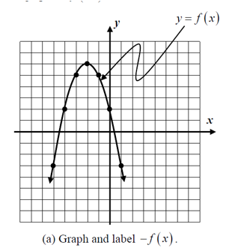
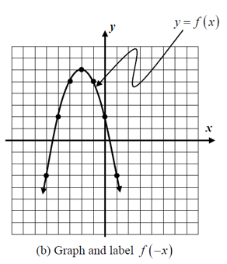
- Sketch the transformations.

- If the point $(-3, 12)$ lies on the graph of the function $y=f(x)$, which of the following points must lie on the graph of $y=3f(x)$?

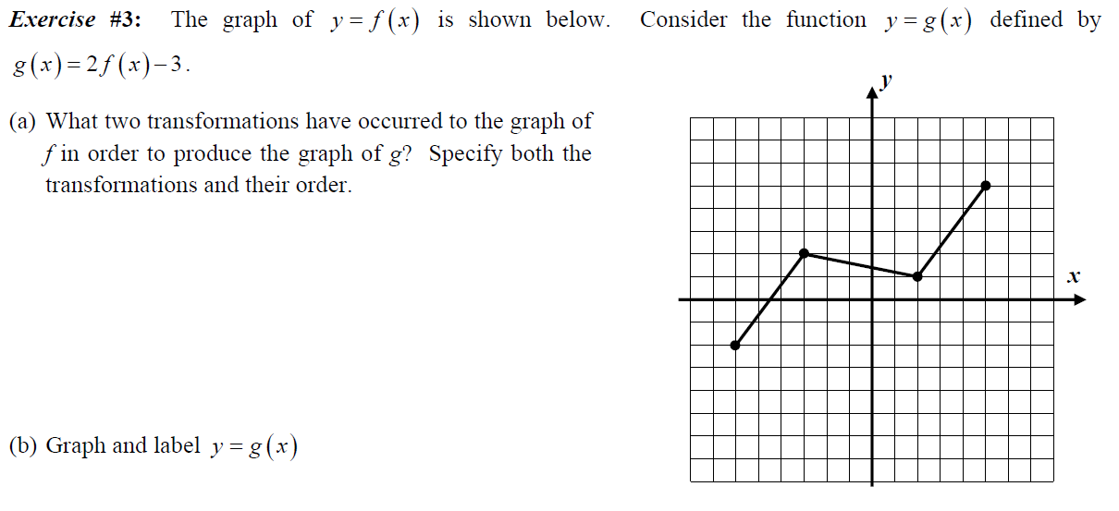

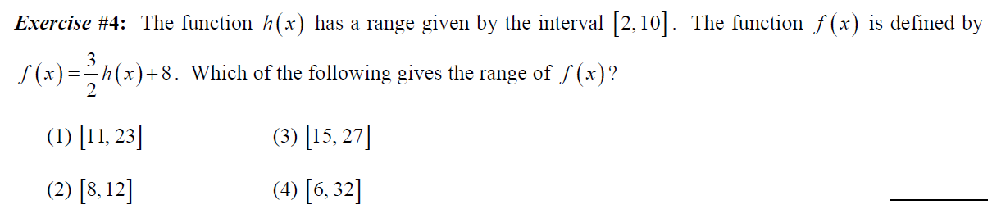

- Give the name of the parent function, describe the transformation represented, and state the domain and range.

- $g\left(x\right)=x^{2}-1$ Name: ________________________________________________________

Transformation: ________________________________________________________

Domain: ________________________ Range : _____________________________

- $f\left(x\right)=-2\left|x-1\right|-6$ Name: ___________________________________________________

Transformation: ________________________________________________________

Domain: ________________________ Range : _____________________________

